From: https://www.strategic-culture.org/news/2018/12/14/us-demands-europe-to-join-its-war-against-russia.html
Derivative From: https://www.zerohedge.com/news/2018-12-14/us-demands-europe-join-its-war-against-russia
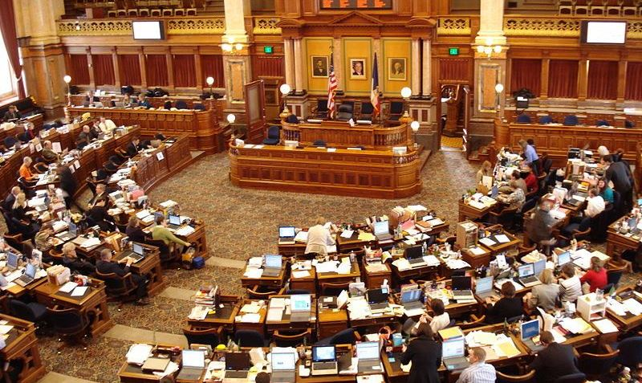
ERIC ZUESSE | 14.12.2018 | WORLD / AMERICAS | FEATURED STORY

US Demands Europe to Join Its War Against Russia
In recent decades, the US Constitution’s clause that requires a congressional declaration of war before invading any country, has been ignored. Furthermore, ever since 2012 and the passage by Congress of the Magnitsky Act sanctions against Russia, economic sanctions by the US Government have been imposed against any company that fails to comply with a US-imposed economic sanction; a company can even be fined over a billion dollars for violating a US economic sanction. And, so, sanctions are now the way that the US Congress actually does authorize a war — the new way, no longer the way that’s described in the US Constitution. However, in the economic-sanctions phase of a war — this initial phase — the war is being imposed directly against any company that violates a US-ordered economic sanction, against Russia, Iran, or whatever target-country the US Congress has, by means of such sanctions, actually authorized a war by the US to exist — a ‘state of war’ to exist.
For the US Congress, the passage of economic sanctions against a country thus effectively serves now as an authorization for the US President to order the US military to invade that country, if and when the President decides to do so. No further congressional authorization is necessary (except under the US Constitution). This initial phase of a war penalizes only those other nations’ violating companies directly — not the target-country. Though the US Government punishes the violating corporation, the actual target is the targeted (sanctioned) country. Sanctions are being used to strangle that target. The fined companies are mere ‘collateral damage’, in this phase of America’s new warfare. In this phase, which is now the standard first phase of the US Government’s going-to-war, the US Government is coercing corporations to join America’s economic war, against the given targeted country — in this case, it’s a war against Russia; Russia is the country that the US Government wants to strangle, in this particular instance.
On Tuesday, 11 December, the US House of Representatives voted unanimously (no member objected), by voice vote — unrecorded so that nobody can subsequently be blamed for anything — that President Donald Trump should impose penalties, which could amount to billions of dollars, against any EU-based corporation that participates with Russia in Russia’s Nord Stream II Pipeline to supply gas to Europe. This “Resolution,” H.Res.1035, is titled “Expressing opposition to the completion of Nord Stream II, and for other purposes,” and it closes by asserting that the US House of Representatives “supports the imposition of sanctions with respect to Nord Stream II under section 232 of the Countering America’s Adversaries Through Sanctions Act.” With no member objecting, the US House thereby warns corporations to cease doing business with Russia, because the US Government is determined that any such business will be terminated and will maybe also be fined. The US Government imposes its will as if it were the dictator to the entire world, and without even needing to use its military, but just economic coercion.
From: Bloomberg
Heading: U.S. House Passes Resolution Opposing Russian Gas Pipeline
By Stephen Cunningham and Ari Natter
December 11, 2018, 4:08 PM EST
SubHeading: Gazprom’s Nord Stream 2 to bypass Ukraine, bring gas to EU
Non-binding resolution calls for governments to reject project

The U.S. House of Representatives approved a largely symbolic resolution expressing opposition to Gazprom PJSC’s $11 billion Nord Stream 2 natural gas pipeline, on concerns that the project will boost the Kremlin’s control over Europe’s energy supplies.

The bipartisan bill finds that the pipeline is a "drastic step backwards for European energy security and United States interests," and calls for European governments to reject the project. The measure also urges President Donald Trump to "use all available means to support European energy security."

While the resolution is non-binding, it highlights growing Congressional opposition to the Russian project. The Trump administration is reviewing potential sanctions against the European companies involved. The pipeline, which would send Russian gas to Germany, has financing agreements with Engie SA and Royal Dutch Shell Plc, among others.

“Doing business with Nord Stream 2 is not consistent with shared transatlantic values,” U.S. Assistant Secretary for Energy Resources Francis Fannon said on a conference call earlier in the day.

The pipeline is one of several Russian projects that would
- circumvent Ukraine and
- give the world’s top gas producer direct access to its biggest European markets.

Trump last year signed a law giving him the right to sanction companies involved in Nord Stream 2, arguing it would make Germany “captive” to Moscow. In response, Moscow said Trump’s attacks were an attempt to promote U.S. liquefied natural gas in Europe.

The US Senate doesn’t yet have a similar bill, but the unanimous passage of this one in the House constitutes a strong warning to Europe’s corporations, that unless they obey the US sanctions, huge financial penalties will be imposed upon them. There are not many issues on which the US Congress is even nearly 100% united in agreement, but during this phase, the introductory phase, of America’s war against Russia, the war against Russia is certainly among those few instances — entirely bipartisan.
According to RT, on December 12th, headlining “US lawmakers want to put a cork in Russia's gas pipeline to Europe”: "On Monday, Austria's OMV energy group CEO Rayner Zele stated that the company is set to continue financing the pipeline next year. OMV has already invested some 531 million euros ($607 million) into the project, Zele told Ria Novosti. In early December, German Foreign Minister Heiko Maas also said that Berlin’s abandoning the project would not make sense as Russia will still go on with it. Germany earlier rebuked Trump’s criticism of the project after the US leader accused Berlin of being a ‘captive’ of Moscow citing Germany’s alleged dependency on natural gas from Russia.”
If the US Government fails to strangulate the economies in the countries such as Russia and Iran against which it has imposed sanctions, then the next step, of course, would be some type of armed invasion of the given targeted country. Before the US invaded Iraq in 2003, America’s economic sanctions killed from 100,000 to 500,000 Iraqi children, but then the US invaded and destroyed the country vastly more than just that.
Economic sanctions are an attempt to coerce a targeted country’s — in effect — surrender, but without needing to use a military invasion as the coercive means. Any sanctioned country is therefore in America’s bomb-sights, and will be conquered in one way or another, unless the US Government backs down, at some point.
According to the most extensive study that was ever done of US military bases worldwide, there are over a thousand such bases, and this is a huge multiple of all non-US military bases put together. That study was published in 1995. Many new US military bases have been built and manned since 1995, such as several dozen in just one country, Syria, where the sovereign Government has never invited them in and many times has ordered them to leave, but they refuse to leave. Currently, the US Government spends more than half of all monies that are being spent worldwide on the military.
Regarding the Nord Stream II Pipeline, the beneficiaries if that Pipeline is never completed and placed into service, will be American LNG (Liquefied Natural Gas) producers, and also America’s allies such as Saudi Arabia and Israel. World War III could actually start as a result of the US Government’s serving America’s (and its allies’) fossil-fuels producers above all other concerns regarding not only global warming, but even world peace itself. Those are the interests that are, in effect, at war against the entire world. This is not a statement of opinion: it is established and well-demonstrated fact. It is the overwhelmingly documented reality.
Tags: Nord Stream Sanctions

